* -: Thus far, we've learned a lot about the template driven approach and now we can create great forms with it.
* Now let's move on.
* Let's leave the world of validating user input here.
* And let's say we want to ***define some default values which should be displayed.***
* For example on the dropdown here right now it's empty by default.
* Well, it would be nice if one of the two questions would be selected, right? ***For this we can change the way we add ngModel right now.***
* We add it like this without property or event binding.
* No two-way data binding.
* Well, we can use it together with property binding.
* So let's add some square brackets around it, no parenthesis.
* So we're not using two-way binding as of now.
* And now we can bind it to a value.
* And remember with it, I mean the control, this input here which is turned into a controlled by angler in the background.
* So this selector can now be bound to a default value.
* And you could either hard code a string into there, don't forget the single quotation marks in this case.

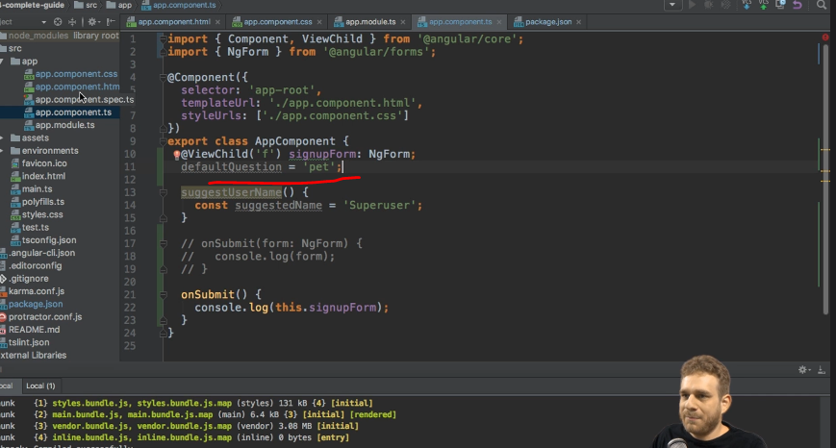

* Or you set up a property like let's say, default question which would be Pet.
* Pet because that is one of the two valid values.
* The other one being teacher for this question here.
* So now we can bind this to default question.

* And if we now save this and let it reload, you see that now Pet is selected.
* And of course if we switch this to Teacher, well it shouldn't be a surprise that the other value is selected.
* So now all of a sudden we're using a default value.

* And of course this does not only work for the dropdown it would also work for the username.
* You could point to a default string there pre-populating this field with a default username.
* Very useful and something you should definitely keep in mind that you are not limited to using ngModel without any bindings.
* You can use one way binding, property binding to set a default value.
* Of course, this value can still be overwritten.
* You can still pick a different option here.